

TELANGANA TRIBAL WELFARE RESIDENTIAL DEGREE COLLEGE (WOMEN)
TIRUMALA HILLS, APPANAPALLY, MAHABUBNAGAR DISTRICT – 509001
Email: ttwrdcgirls.mahabubnagar@gmail.com, 7901097704, 7901099768

ACTIVITY: 01

DIAMOND JUBILEE CELEBRATIONS.
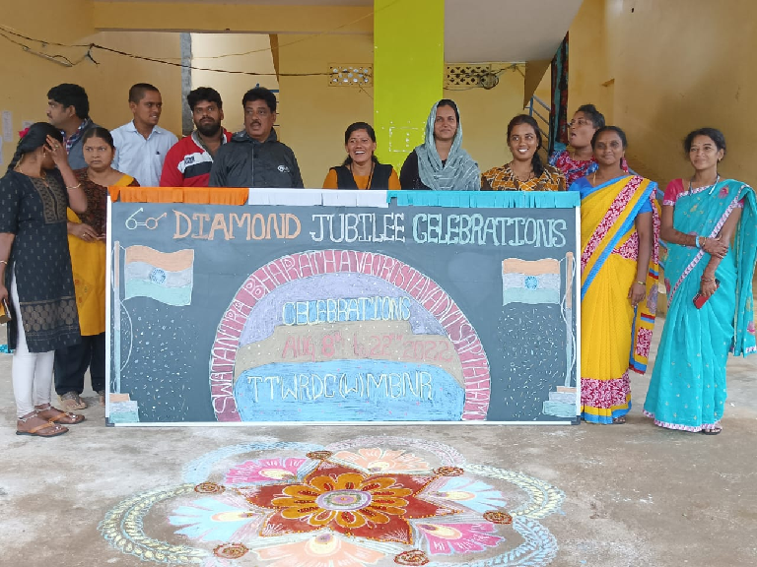
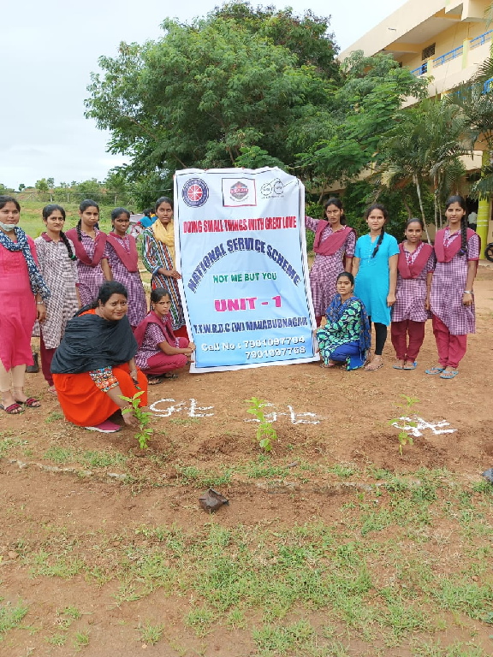

ACTIVITY :02

STUDENTS COUNCIL ElECTIONS.

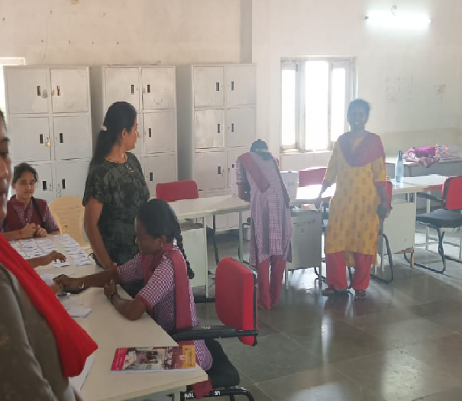
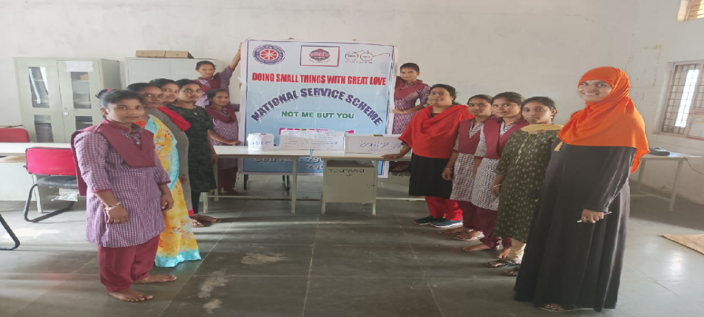

ACTIVITY :03

55th NATIONAL LIBRARY WEEK CELEBRATIONS.
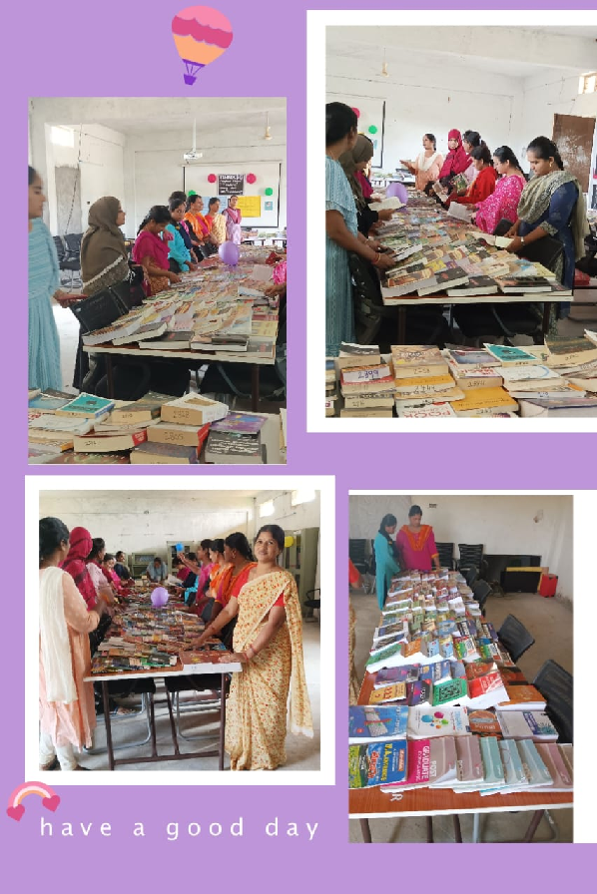

ACTIVITY :04

WORLD AIDS DAY.

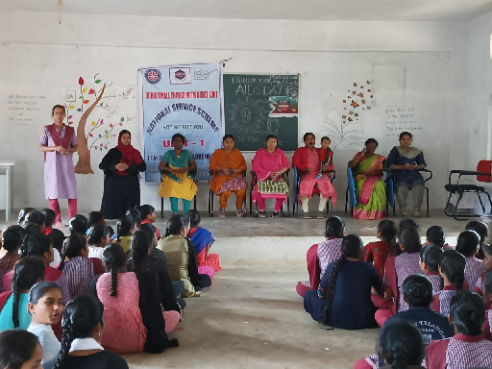

ACTIVITY :05

INTERNATIONAL V0LUNTEERS DAY.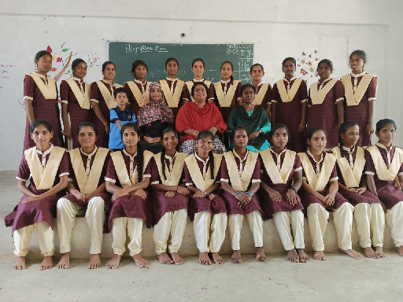

ACTIVITY :06

NATIONAL MATHEMATICS DAY CELEBRATION.
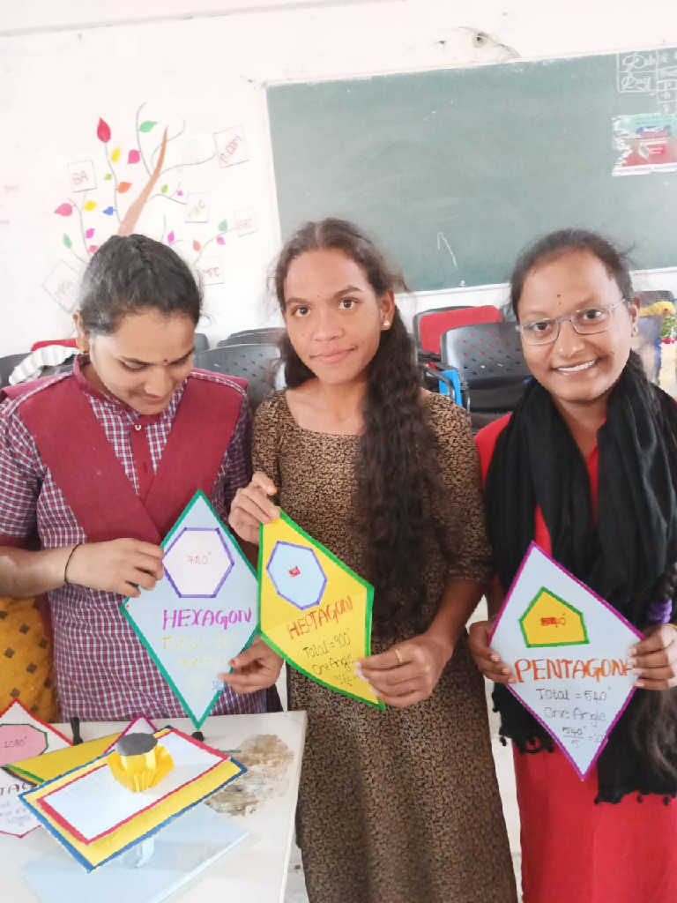

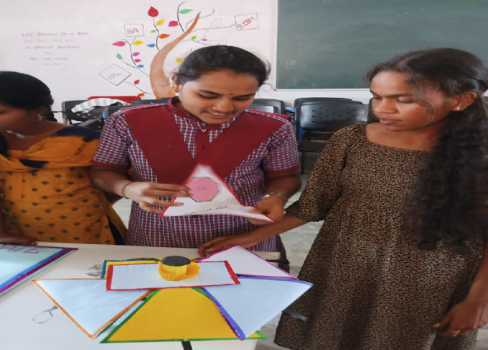

ACTIVITY :07

SAVITHRI BAI PHULE JAYANTHI.

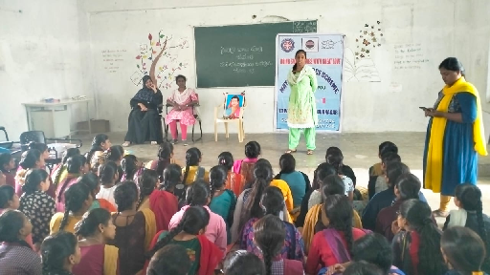

ACTIVITY: 08

NATIONAL YOUTH DAY.

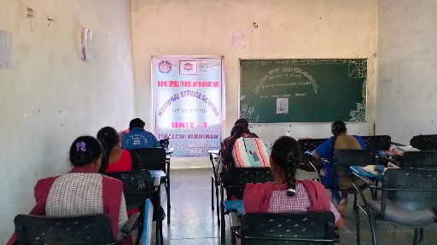

ACTIVITY :09

NATIONAL VOTER DAY.

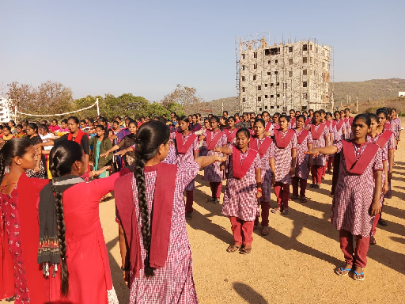

ACTIVITY : 10

SANTH SEVALAL MAHARAJ JAYANTHI

ACTIVITY :11

INTERNATIONAL MOTHER LANGUAGE DAY.
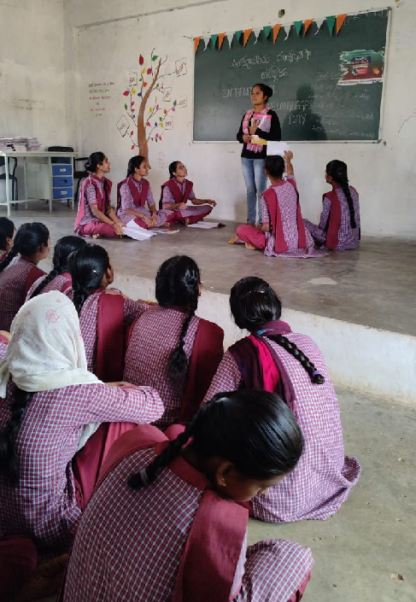

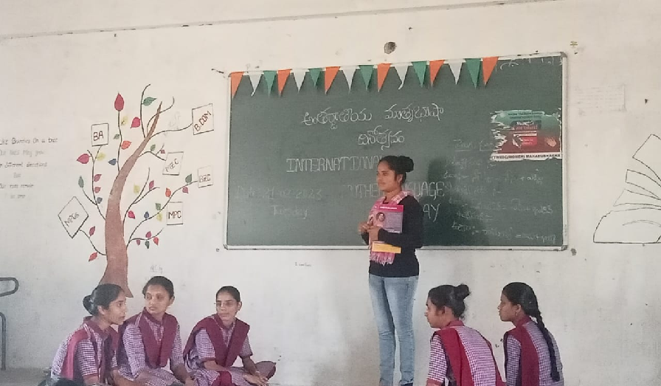

ACTIVITY :12

NATIONAL SCIENCE DAY .
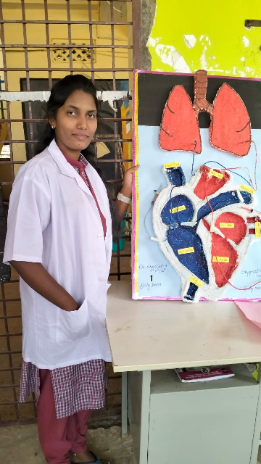
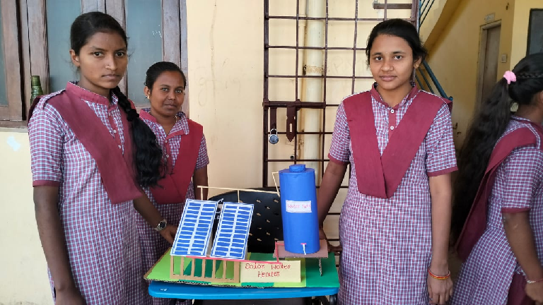
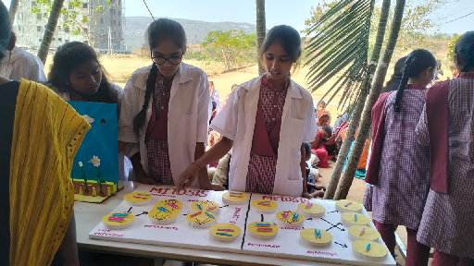

ACTIVITY :13

ZERO DISCRIMINATION DAY.
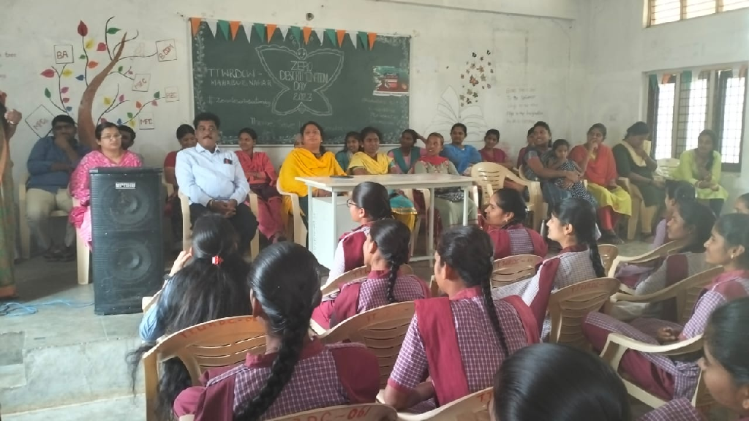

ACTIVITY :14

VISIT TO GOVT. BLIND SCHOOL.
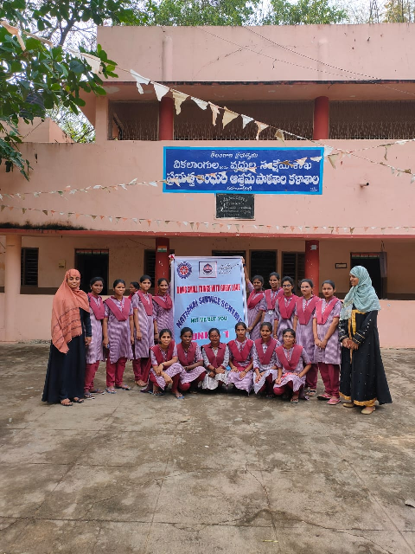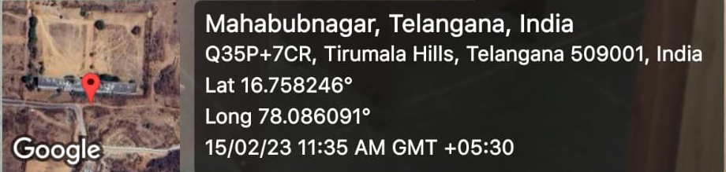

ACTIVITY :15

INTERNATIONAL WOMEN’S DAY

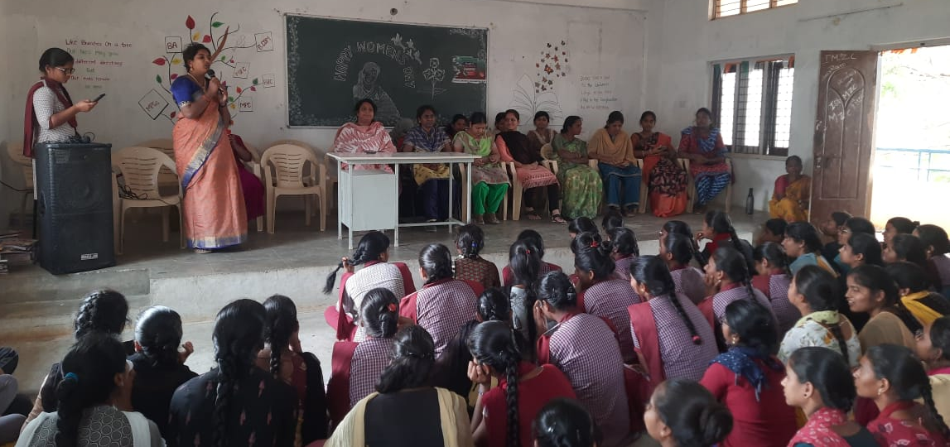

ACTIVTITY :16

EYE CHECKUP PROGRAMME .
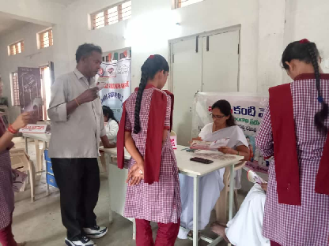

ACTIVITY :17
BRICKS MANUFACTURING FILED VISIT THIMMASANIPALLY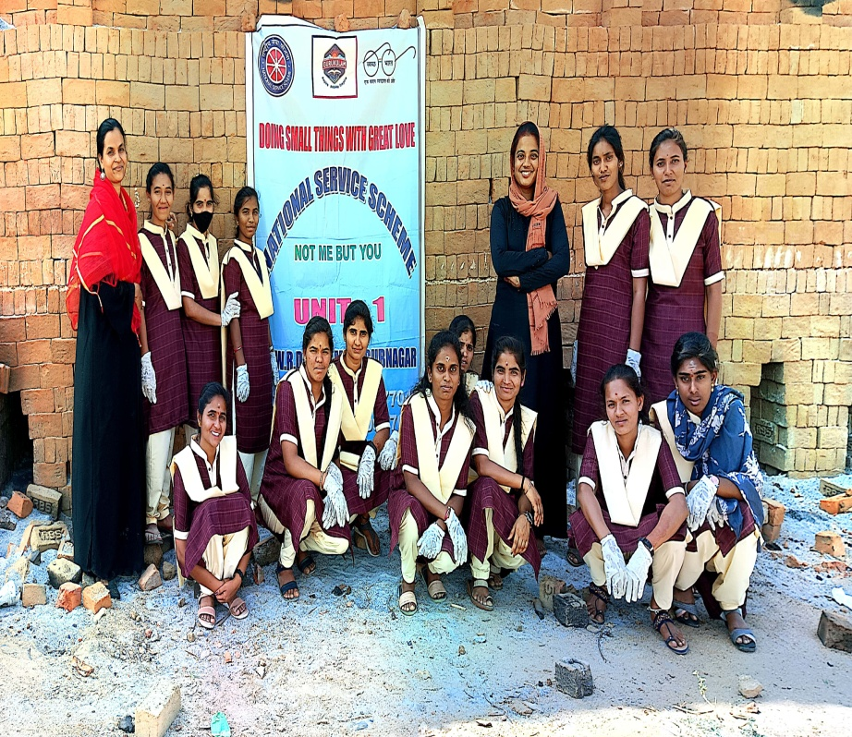
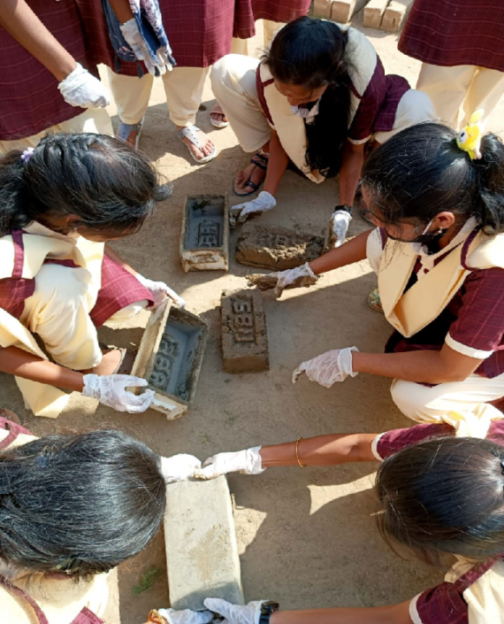
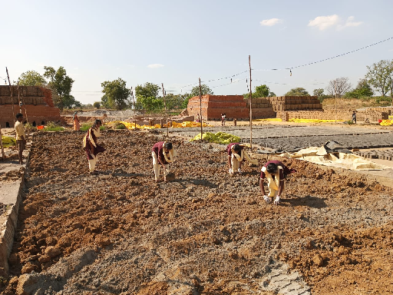
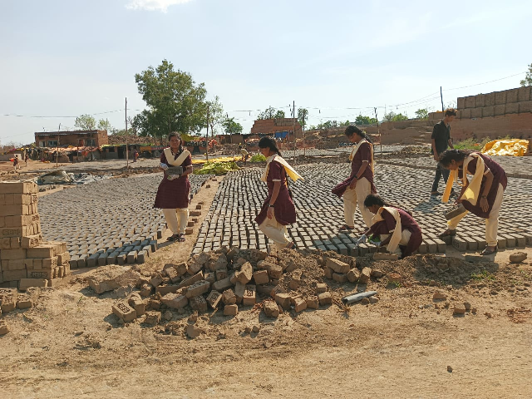

ACTIVITY : 18

RICE CROP FILED VISIT.
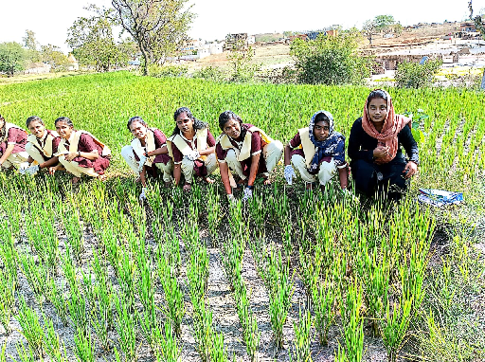

ACTIVITY :19

Dr.B.R.AMBEDKAR JAYANTHI.
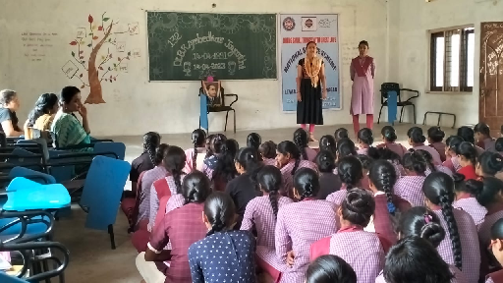

ACTIVITY : 20

WORLD MALARIA DAY.
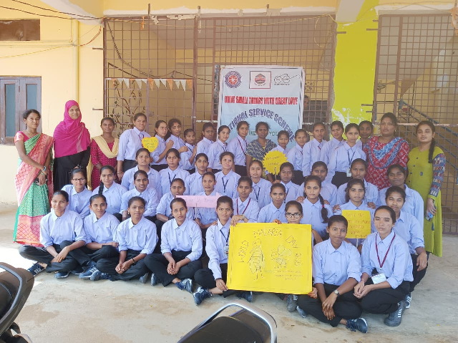

ACTIVITY : 21

COLLECTION OF LITTER IN PUBLIC PARK.
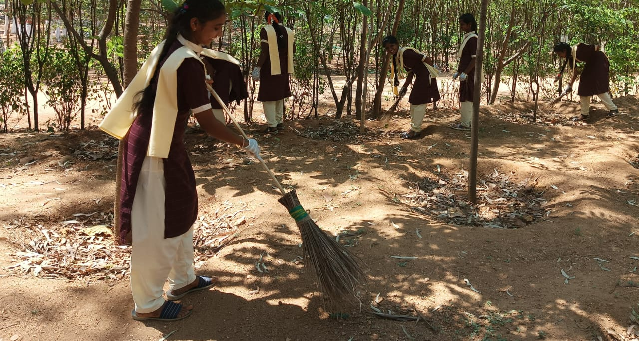

ACTIVITY :22

FAREWELL PARTY CELEBRATIONS.
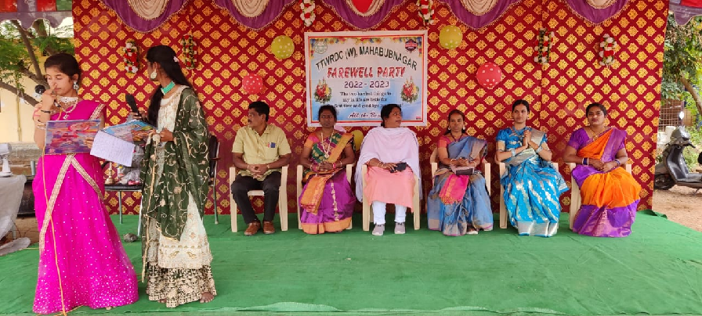

ACTIVITY :23

TELANGANA EDUCATION DAY.

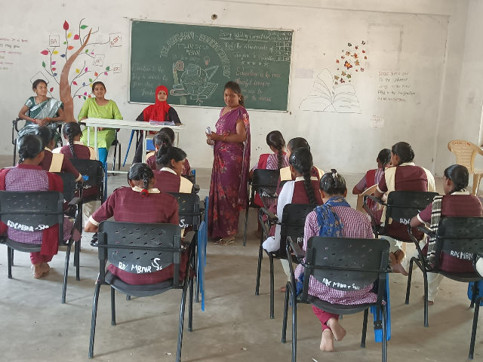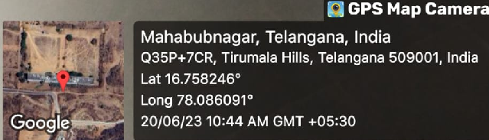

ACTIVITY :24

TELANGANA SPIRITUAL DAY.
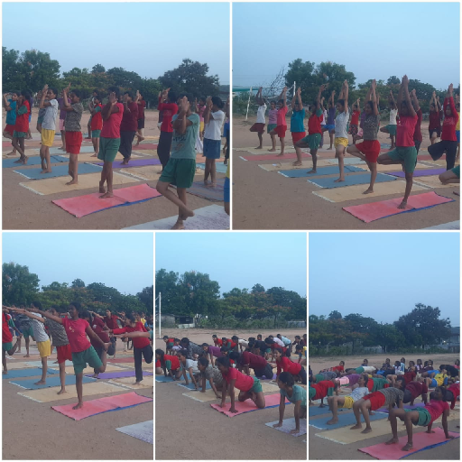

ACTIVITY :25

BLOOD SCREENING CAMP .

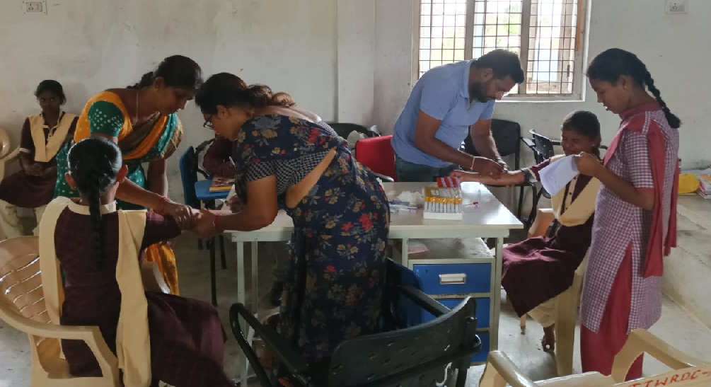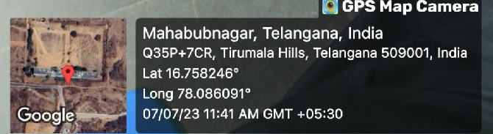

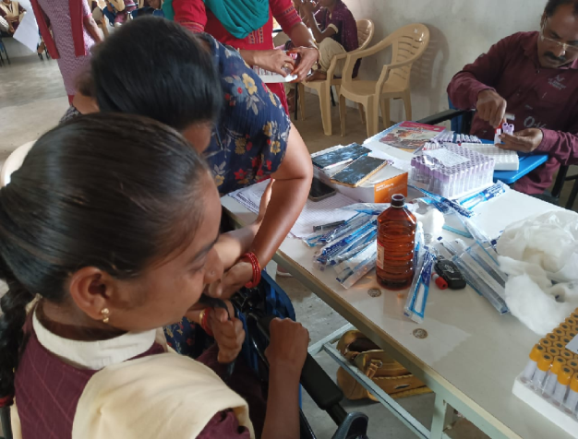

ACTIVITY :26

WORLD ZOONOSESS DAY

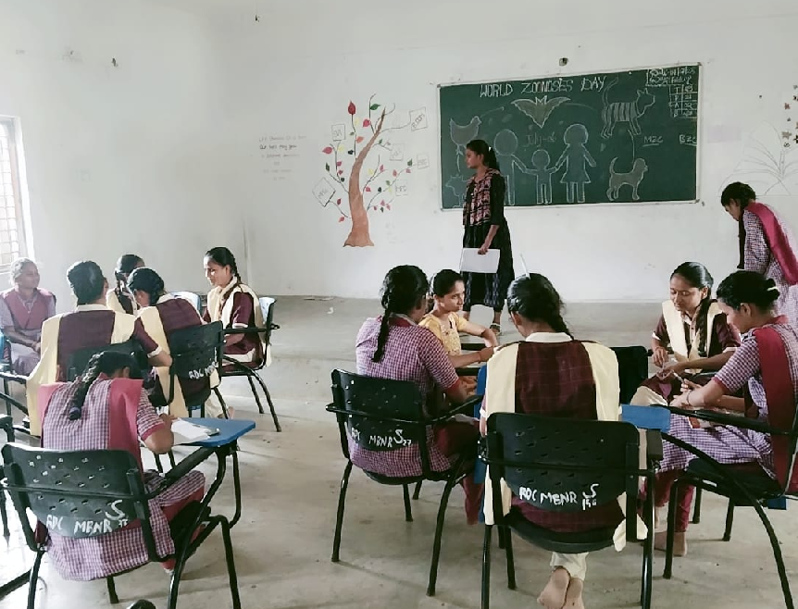

ACTIVITY : 27

A VISIT TO RICE MILL.
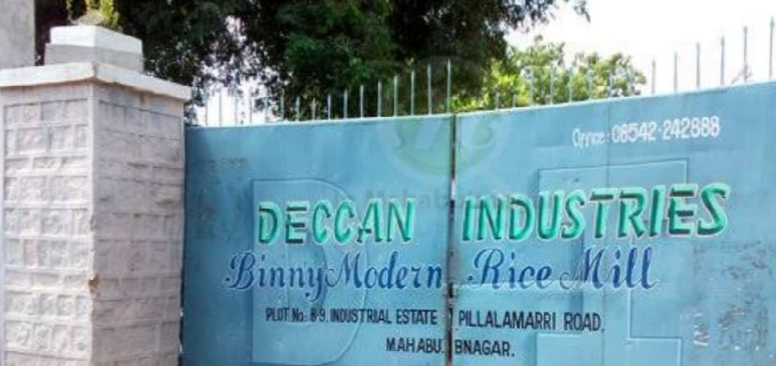

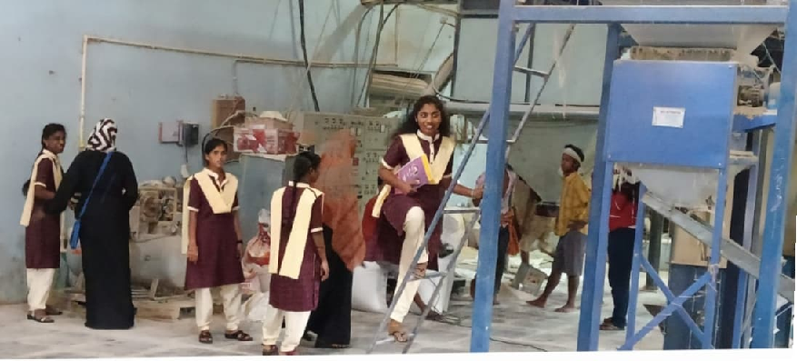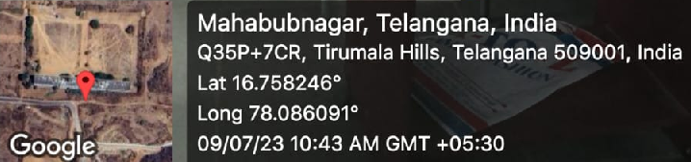

ACTIVITY : 28

MERA MATI- MEERA DESH.

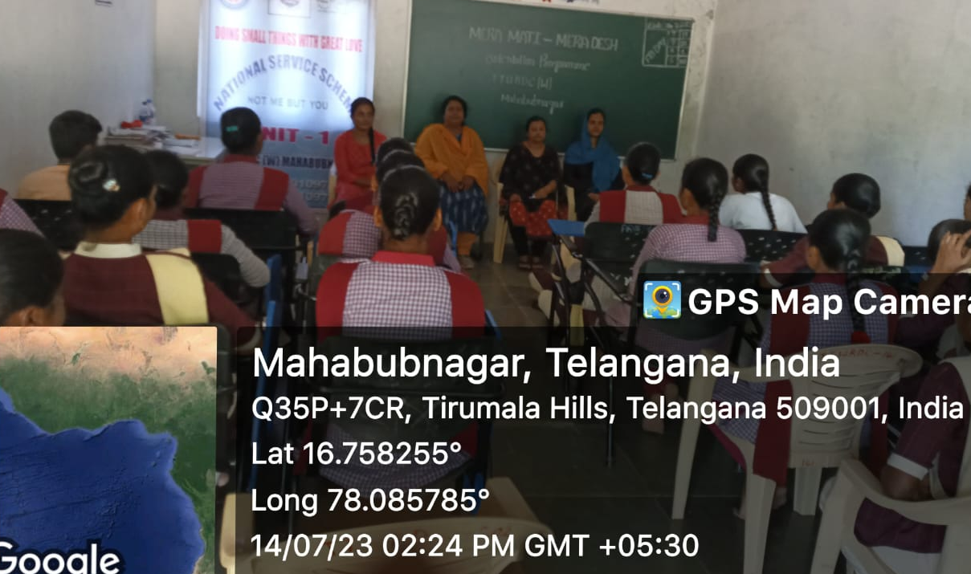

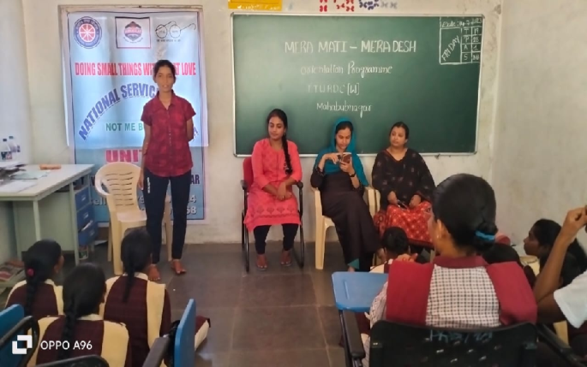
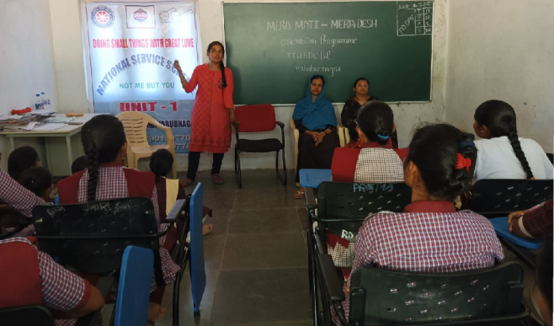

ACTIVITY : 29

GREEN BELT AWARENESS .
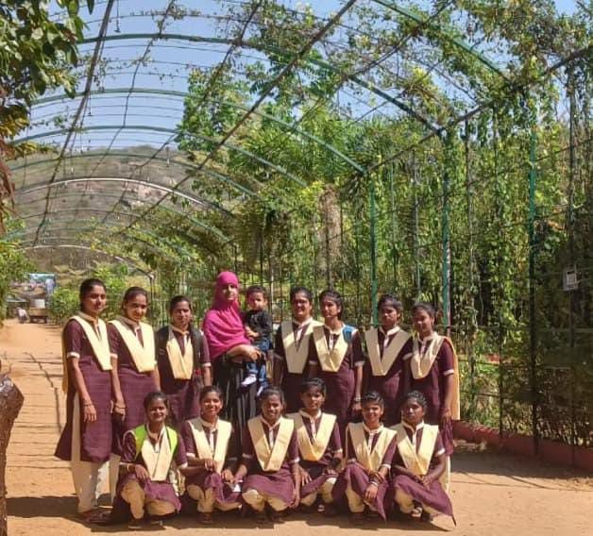
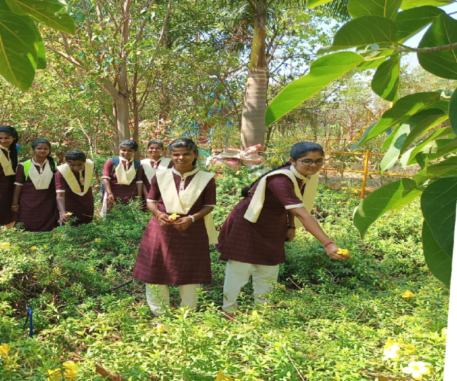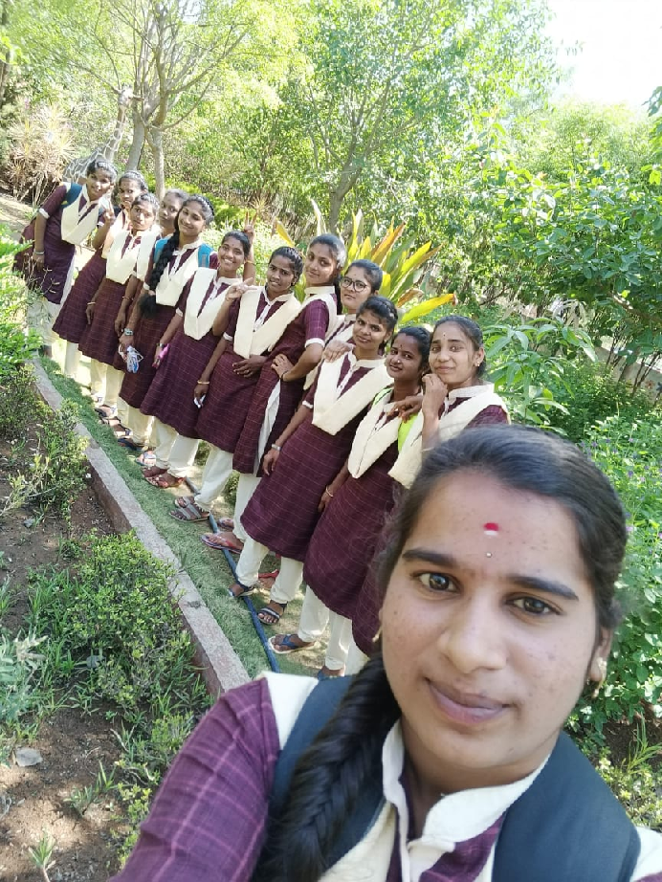

ACTIVITY : 30

PROF . KOTHAPALLY. JAYASHANKAR BIRTHDAY CELEBRATIONS.

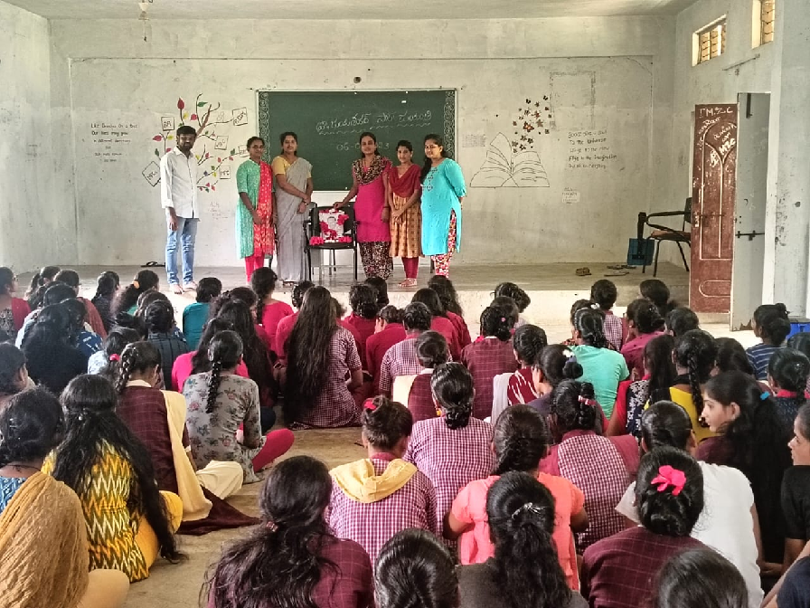

ACTIVITY : 31

PANCHA PARN PLEDGE. 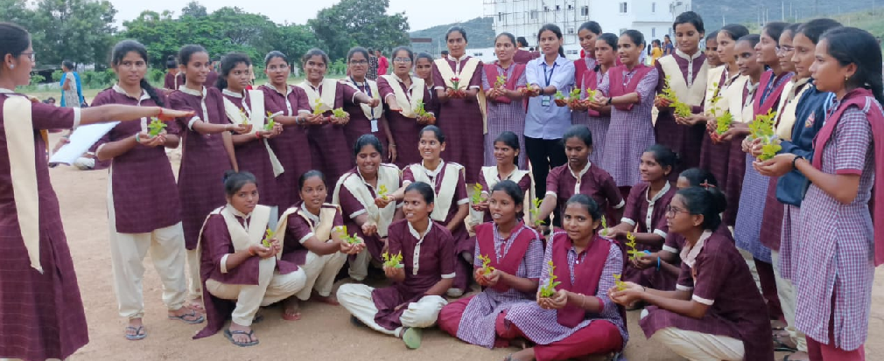

ACTIVITY : 32

INDEPENDENCE DAY CELEBRATIONS.
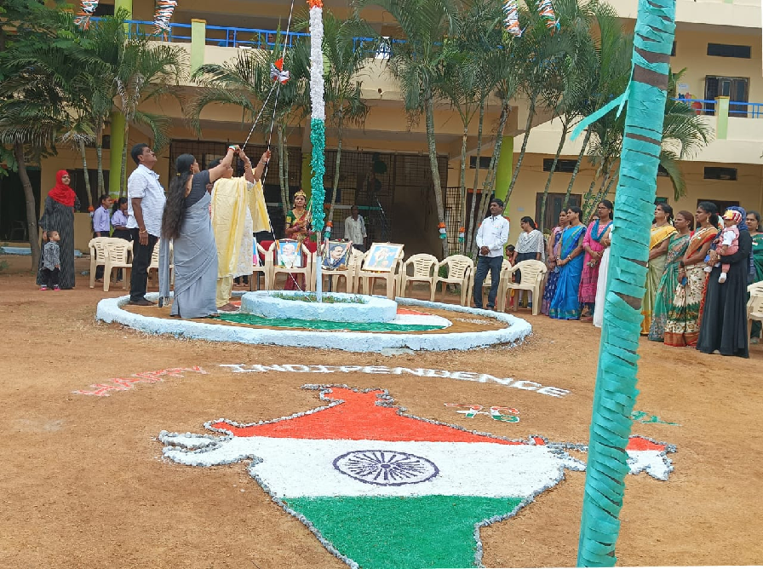

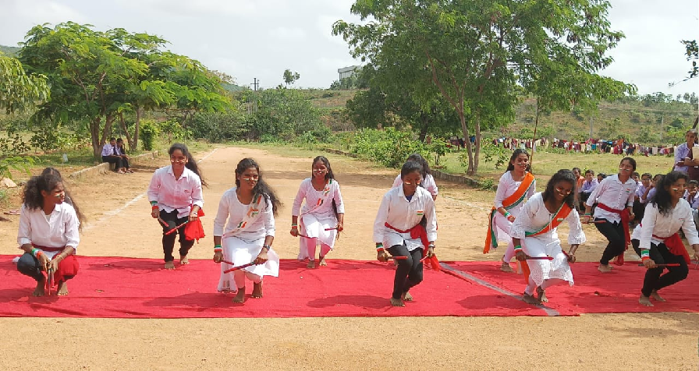

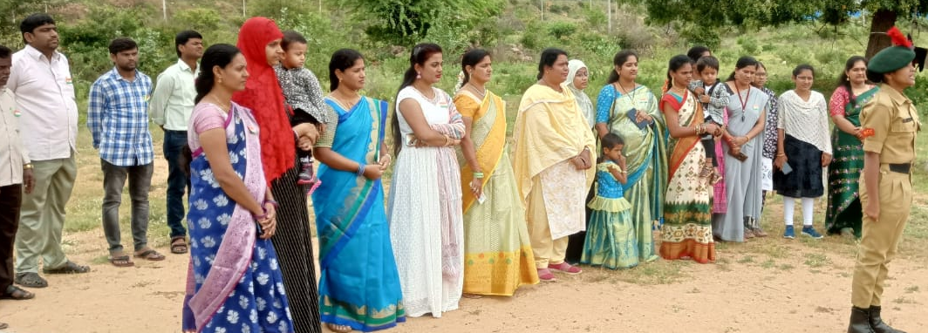

ACTIVITY : 33

SWACHHTA HI SEVA.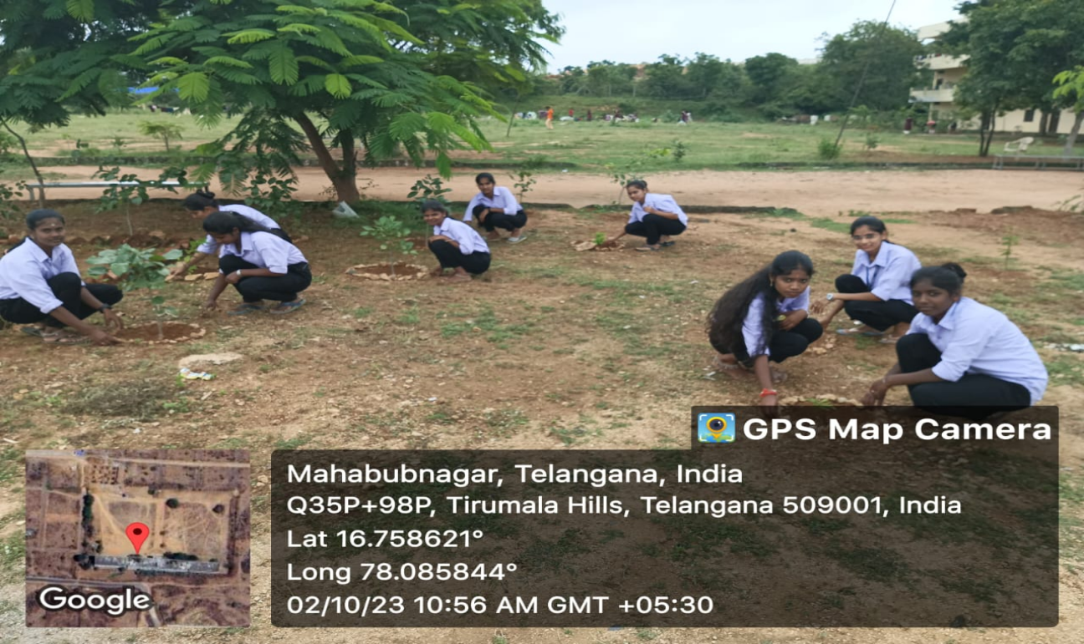

ACTIVITY : 34

INTERNATIONAL DAY OF NON -VOILENCE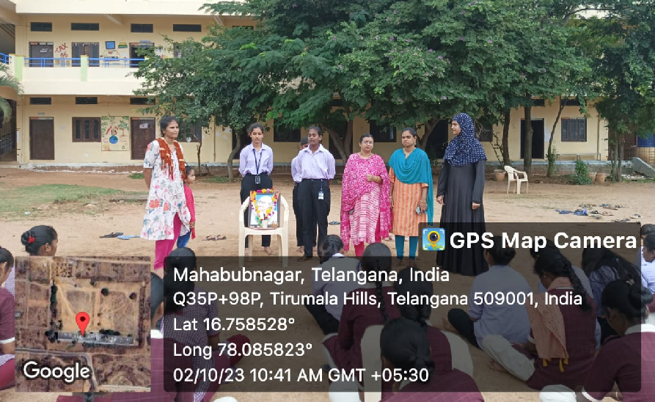.
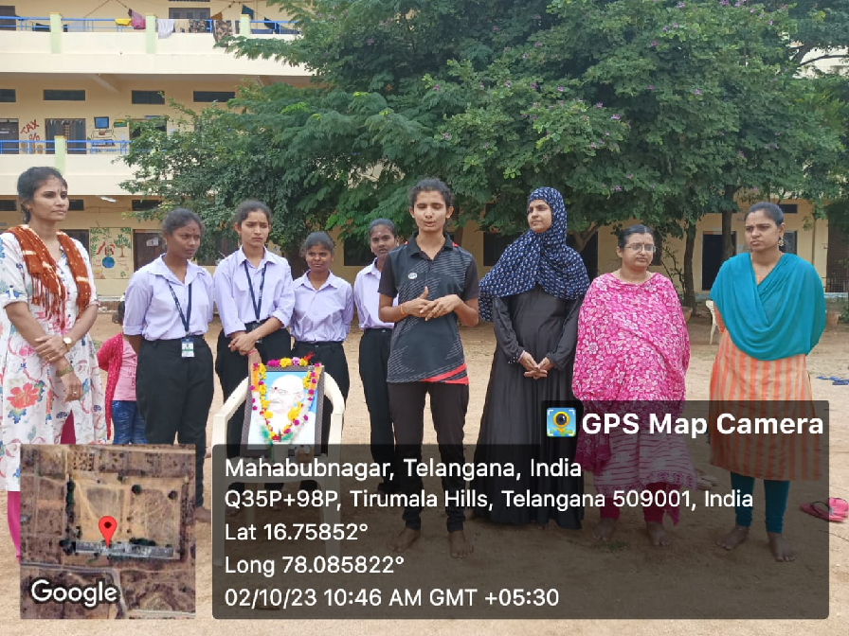
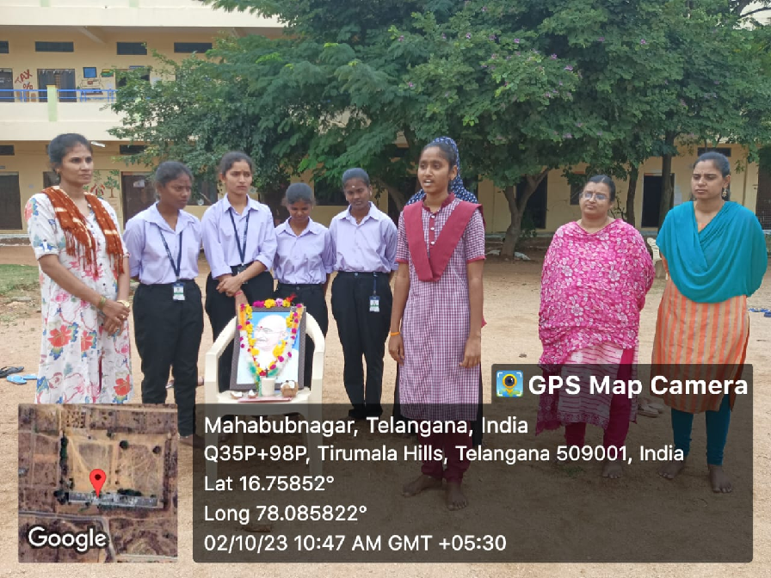

ACTIVITY : 35

STUDENTS COUNCIL ELECTIONS-2023.
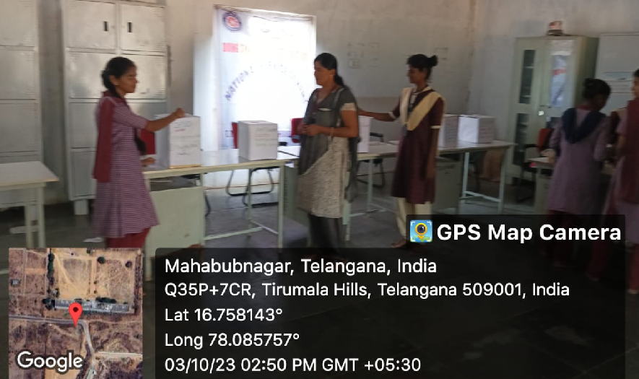
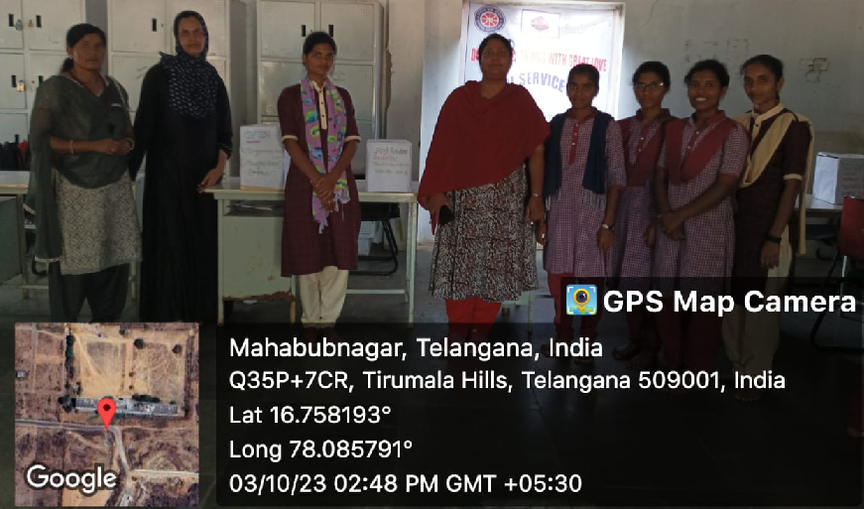
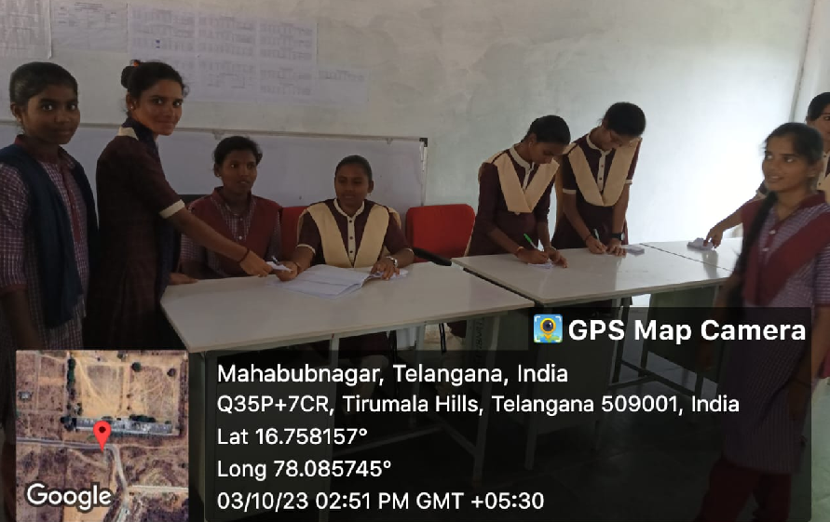

ACTIVITY : 36

AWARENESS OF SEASONAL DISEASES.
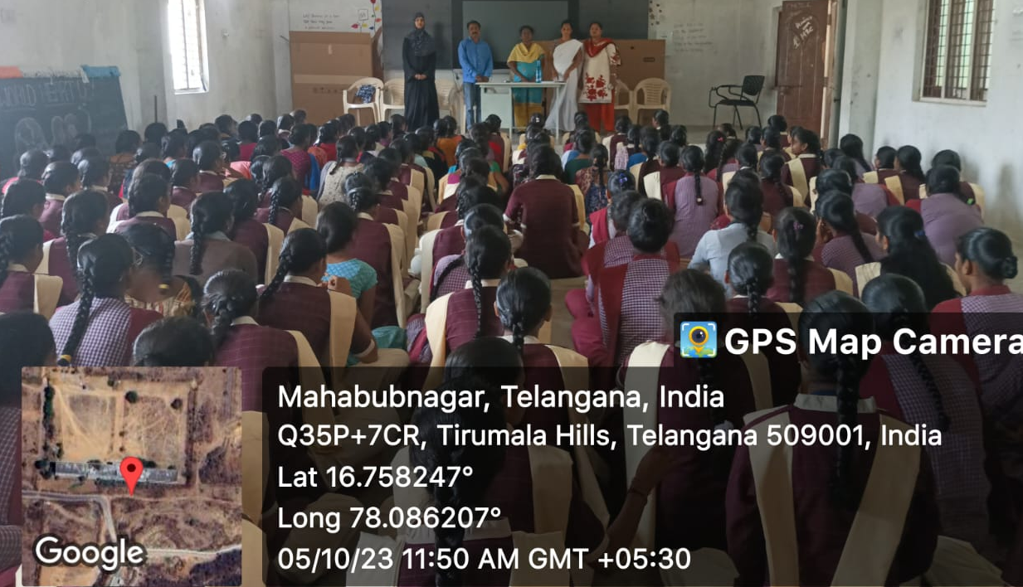

ACTIVITY : 37

NATIONAL UNITY DAY.

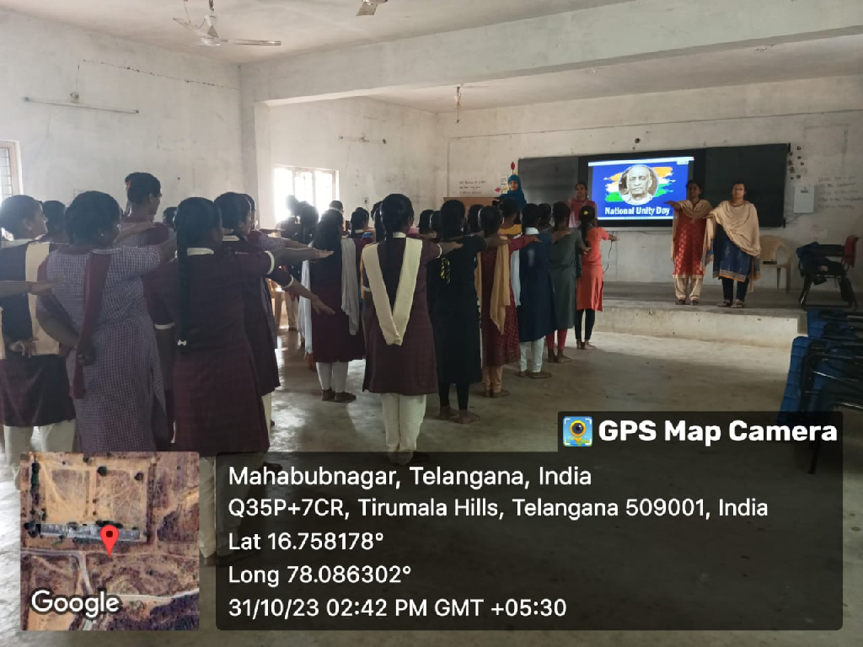

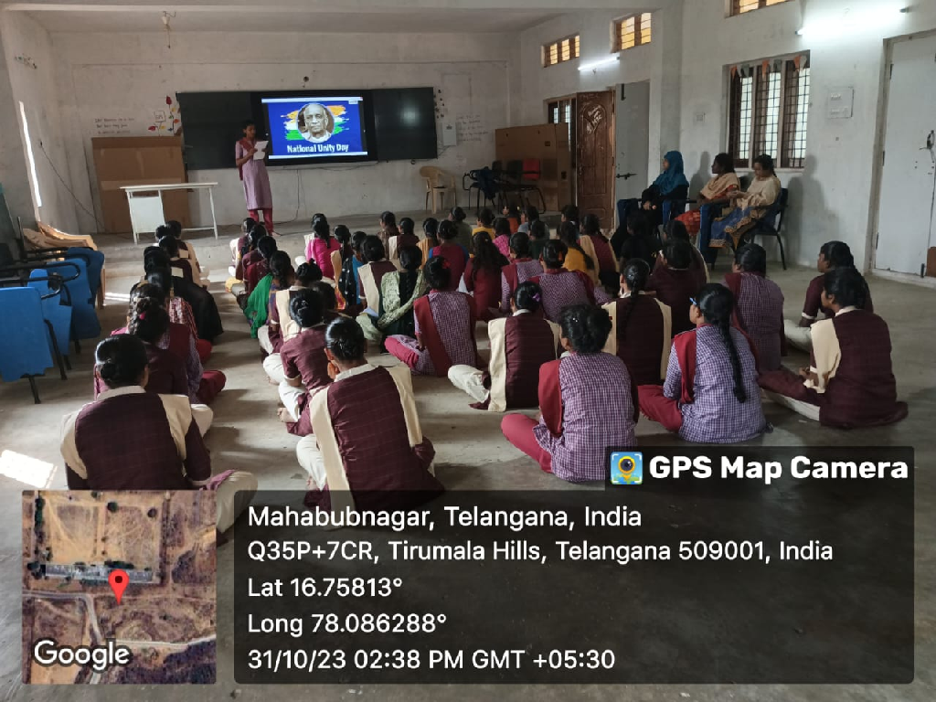

ACTIVITY : 38.

56th NATIONAL LIBRARY WEEK CELEBRATIONS.

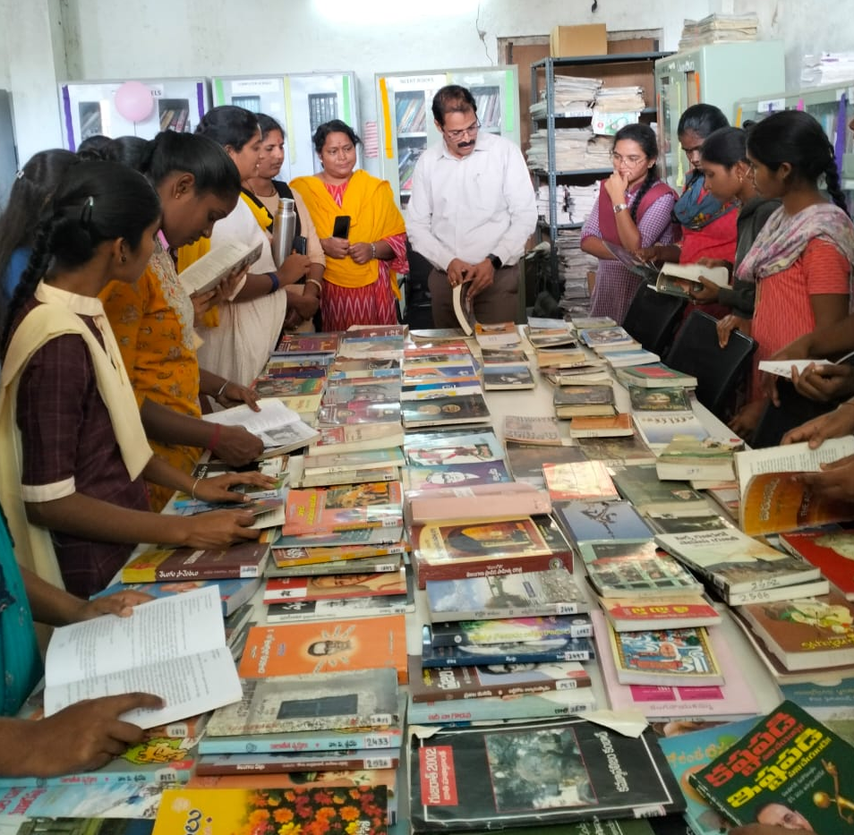

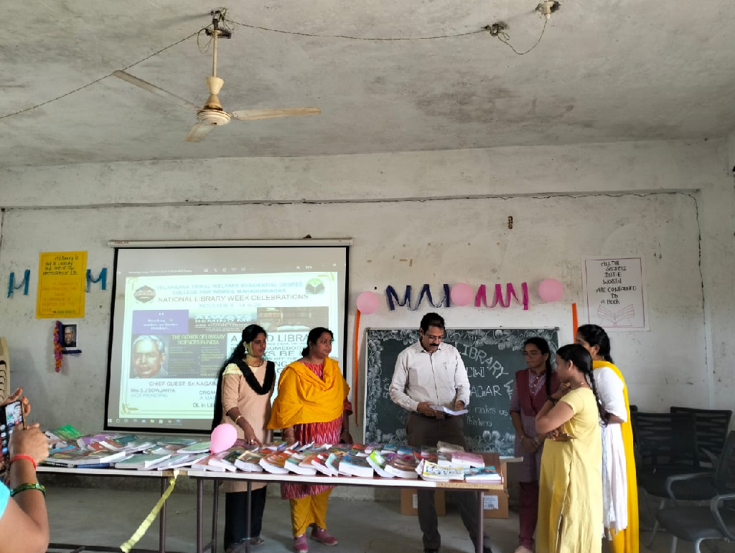

ACTIVITY : 39

ELIMINATION OF VIOLENCE AGAINST WOMEN’S.

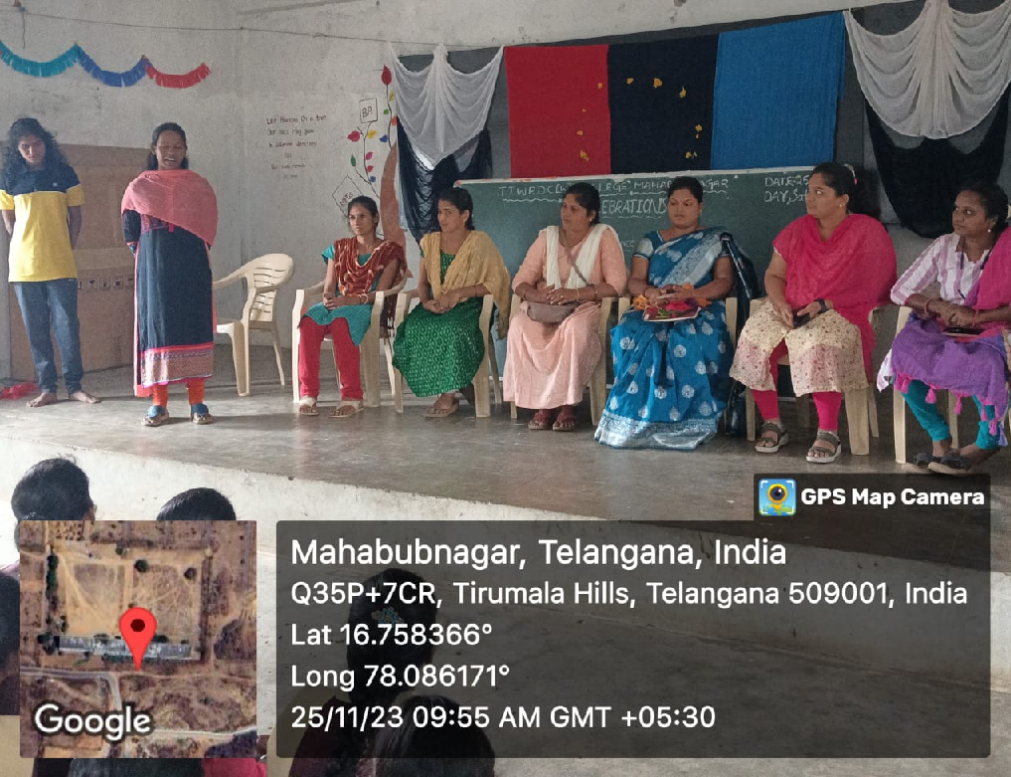

ACTIVITY : 40

CONSTITUTION DAY OF INDIA.
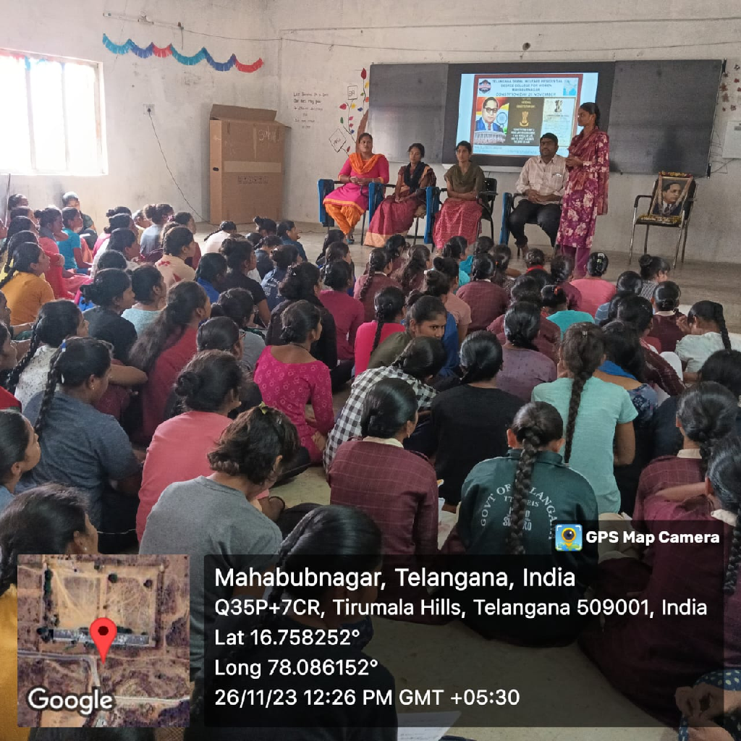
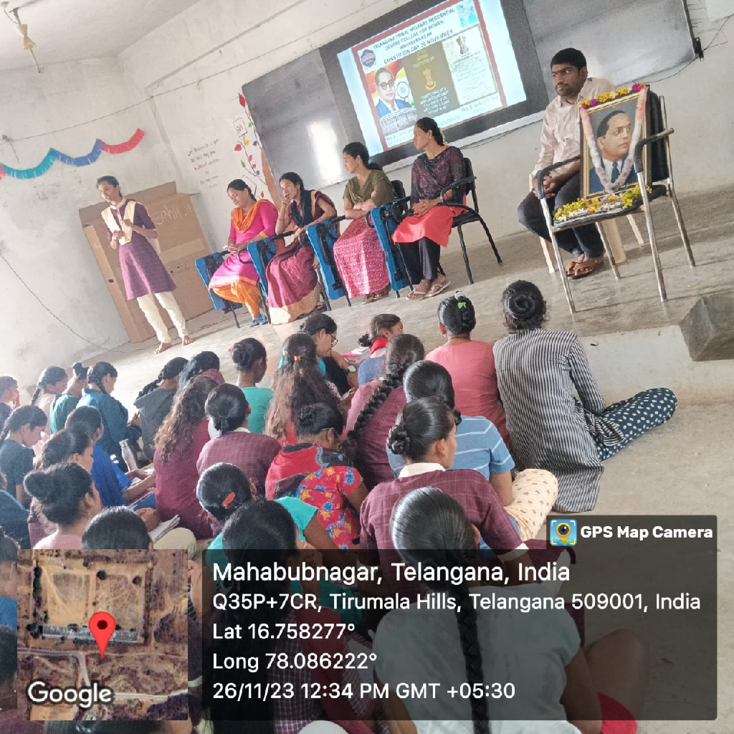
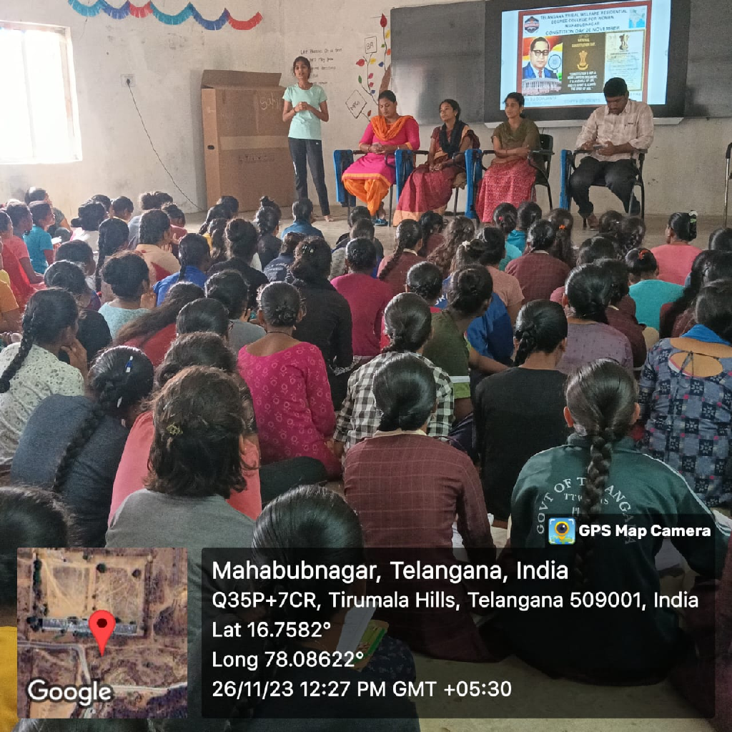

ACTIVITY : 41

NATIONAL MATHEMETICS DAY CELEBRATIONS.

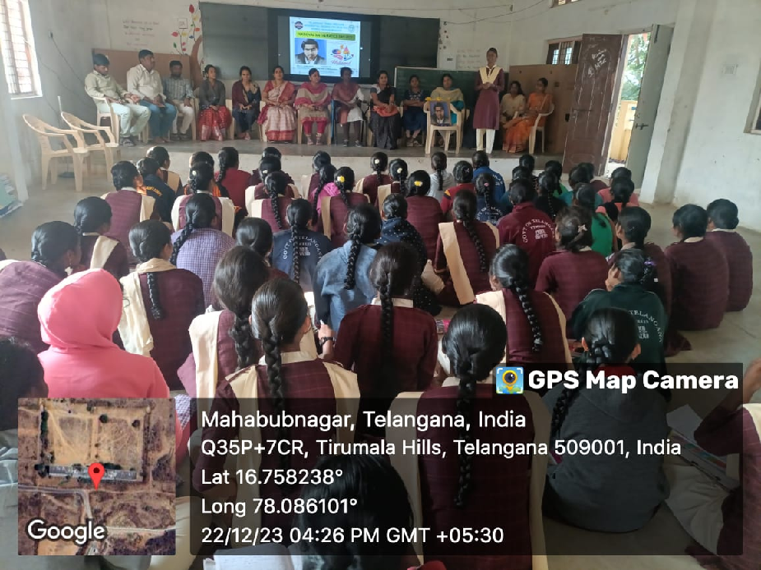

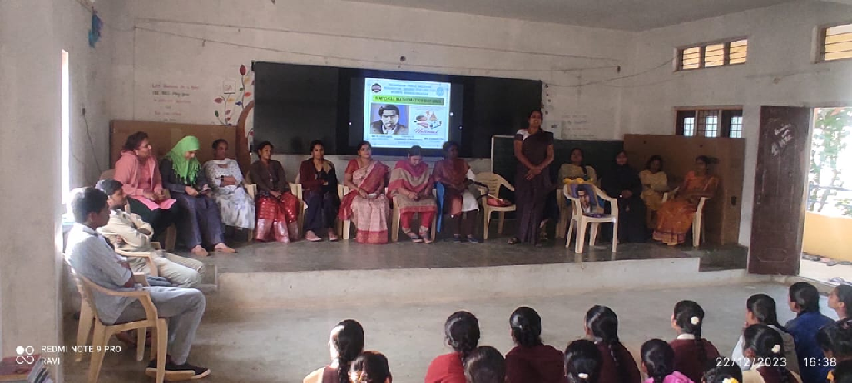

ACTIVITY : 42

WORLD ASTHAMA DAY.
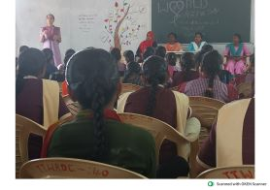
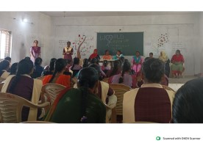

ACTIVITY : 43
SWACHH GURKUL PROGRAMME.
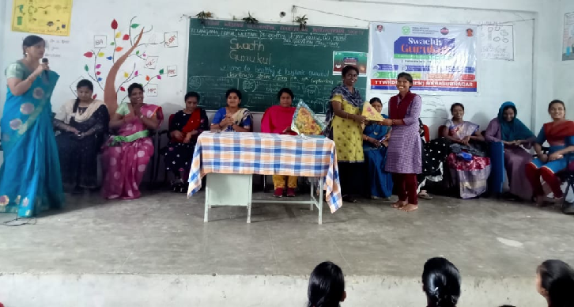
A DRAMMA ON IMPORTENCE OF AGRECULTURE .
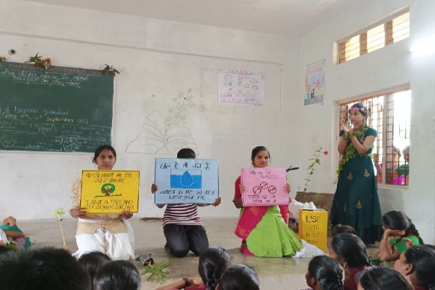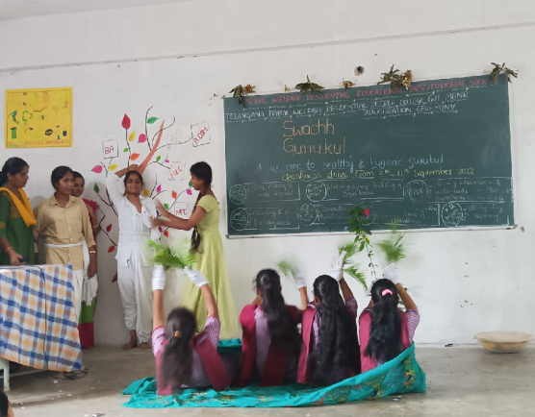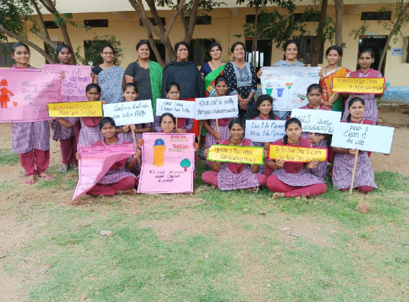
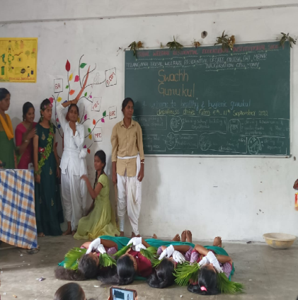

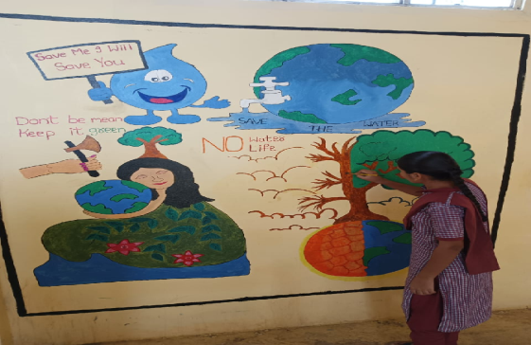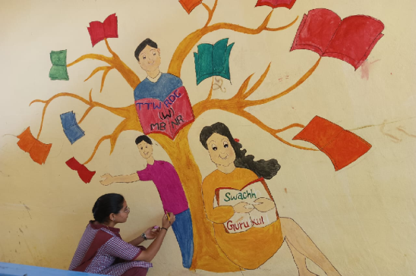

ACTIVITY : 44

CHARMINAR VISIT.
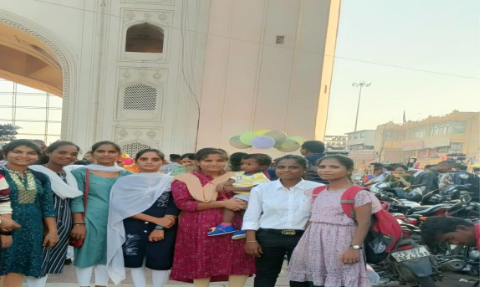

ACTIVITY :45

PLANTATION DRIVE.
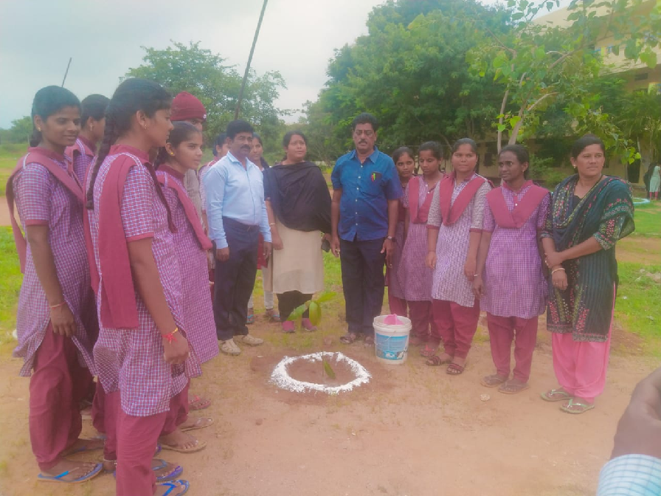
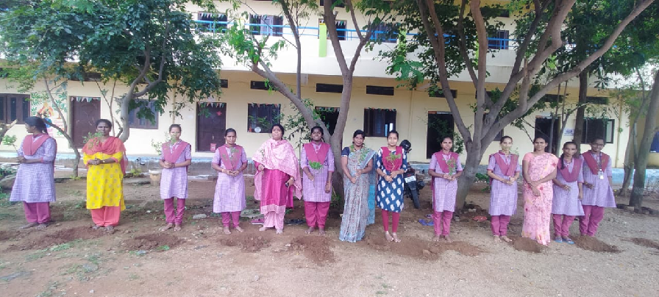

ACTIVITY : 46

TELANGANA STATE SECRETARIAT VISIT.

